Onboarding Passport
Everything needed to onboard
the future leaders of CIEE.

You never get a second chance to make a first impression.
4% of new hires leave after a disastrous first day
22% of turnover occurs within the first 45 days

Onboarding is a critical point in the talent lifecycle. A solid program not only bridges the gap between candidate experience and employee experience, but it also acts as a catalyst for employee satisfaction and retention.

So, to help you succeed, we’ve created this toolkit. From inspiring examples to practical guides, this Onboarding Passport is full of essential resources for every stage of the process.

Happy onboarding,

The CIEE Team

4

What’s Inside?

5

Pre-Boarding

7 1102

Boarding Pass

8 76

Meet the Crew

9

Flight Plan

Takeoff

Pre-Boarding

This section has 1 manager resource and 1 manager template (fillable email).

Please don’t hesitate to engage with your new hire before their first day. It’s a great way to communicate how excited you are for them to join and prepare them for success on day one. Use the templates linked below to create a lasting first impression!

Resources/Templates in this section:
- Best Boss Ever Check List (for manager)
  - Remote Role
  - Site-Specific Role
- Pre-Arrival Welcome (for manager)
  - Email Template (click file in browser pop-up)

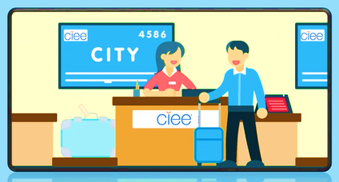

Boarding Pass

This section has 1 manager template (to be edited by manager in employee passport) and 2 employee resources.

The boarding pass section is focused on onboarding and training! These lively videos are centered on building institutional knowledge and know-how. As new employees get familiar with their role and the company, they will refer to this resource daily. We suggest using the template to make it interactive by adding your department specific training using the placeholders that you see in the employee passport.

Resources/Templates in this section:
- Training Checklist (manager to edit in employee passport)
- Frequently Asked Questions (shown in employee passport)
- OneLogin Page (shown in employee passport)

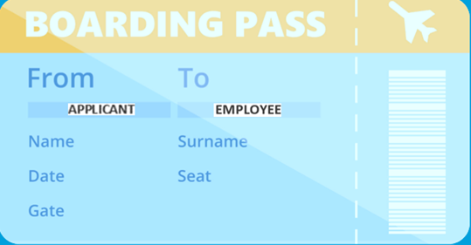

Training Checklist

(PLEASE EDIT IN EMPLOYEE PASSPORT)

Welcome, [employee’s name].
We’re thrilled to have you! Collect your boarding pass by completing the training and watching the videos linked below. Dive in and explore what makes CIEE unique!

Welcome to CIEE!
James Pellow, President & CEO

Learn About CIEE

Learn about CIEE’s commitment to Diversity & Inclusion.

Learn more about CIEE from our People – “CIEE in One Word”

Learn how we make an impact through our Programs.

Complete This Training

Harassment Prevention
(Zywave)

Onboarding Journey – Systems & IT Security
(Bridge)

DEI Foundational
Training
(Bridge)

Ergonomics
Training
(Zywave)

[insert team specific training]

[insert team specific training]

[insert team specific training]

[insert team specific training]

Meet the Crew

This section links out to 3 employee resources.

Let’s shift to meeting the people that keep this plane flying! It’s important for your new hire to piece together how their role fits into the larger team and the organization as a whole. This will also introduce them to our frequently used internal platforms like Viva Engage, our Website and ADP.
Your new hire will use the links below to explore:
      - The Team (using the org. chart in ADP)
      - Leadership (by reading their bios on our website)
      - Your Peers (using our social platform, Viva Engage)

PEERS

TEAM
LEADERSHIP

Flight Plan

This section has 1 manager resource, 1 shared resource and 1 employee resource.

It’s important for you and your new employee to set measurable goals so that they are able to understand what success looks like in their role. In addition to annual goal setting, checking-in on a regular basis ensures they’re provided with support when needed. Doing these things will help ensure that this relationship becomes long-term, and they can cash in on our cool CIEE Airmiles Rewards.

Resources/Templates in this section:
- OKR/Goal Setting Guide (for manager & employee)
- Weekly 1:1 Best Practices (for employee & manager)
- CIEE Airmiles Rewards & Other Rewards (for employee)

Ready for
Takeoff!

You did it - you helped your new team member complete their onboarding! Now, they’re officially ready for takeoff and we can’t thank you enough for helping them get comfortable.

At CIEE, we change lives and our alumni change the world – thank you for being part of the change!

The CIEE Team

