Onboarding Passport

We change lives.
Our alumni change the world.

You never get a second chance to make a first impression.
4% of new hires leave after a disastrous first day
22% of turnover occurs within the first 45 days

Onboarding is a critical point in the talent lifecycle. A solid program not only bridges the gap between candidate experience and employee experience, but it also acts as a catalyst for employee satisfaction and retention.

So, to help you succeed, we’ve created this toolkit. From inspiring examples to practical guides, this Onboarding Passport is full of essential resources for every stage of the process.

Happy onboarding,

The CIEE Team

4

What’s Inside?

5

Pre-Boarding

9 1102

Boarding Pass

10 76

Meet the Crew

11

Flight Plan

Takeoff

Pre-Boarding

Please don’t hesitate to engage with your new manager before your first day. It’s a great way to communicate how excited you are to join and prepare yourself for success on day one. Below are some things to check off your list!

Some things to complete prior to your first day:
- Background check agreement
- Submit your intro/info for our employee newsletter

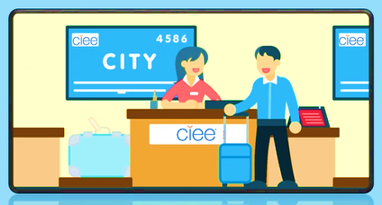

Boarding Pass

This section has 1 manager template (edited/added to by manager) and 2 employee resources.

The boarding pass section is focused on onboarding and training! These lively videos are centered on building institutional knowledge and know-how. As you get familiar with your role and the company, you will refer to this resource often. The next Training Checklist and OneLogin pages link out to videos and platforms that will help get you further acquainted with CIEE!

Resources/Templates in this section:
- Training Checklist (manager to edit/add to)
- Frequently Asked Questions (for employees)
- OneLogin Page (for employees)

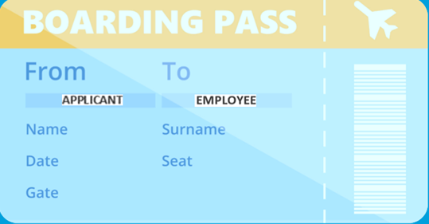

Training Checklist

Welcome,
We’re thrilled to have you! Collect your boarding pass by completing the training and watching the videos linked below. Dive in and explore what makes CIEE unique!

Welcome to CIEE!
James Pellow, President & CEO

Learn About CIEE

Learn about CIEE’s commitment to Diversity & Inclusion.

Learn more about CIEE from our People – “CIEE in One Word” https://www.youtube.com/watch?app=desktop&v=C9K518lk17M

Learn how we make an impact through our Programs.

Complete This Training

Harassment Prevention
(Zywave)

Onboarding Journey – Systems & IT Security
(Bridge)

DEI Foundational
Training
(Bridge)

Ergonomics
Training
(Zywave)

[insert team specific training]

[insert team specific training]

[insert team specific training]

[insert team specific training]

Frequently Asked Questions

What’s the dress code?
CIEE-ers tend to opt for business casual attire. But check-in with your manager ahead of your start date (if you’re a site specific worker) or ahead of any in-person events (if you’re a remote worker).

Who do I contact if I need IT support?
You can always be sure to receive prompt IT support by emailing itsupport@ciee.org.

Who do I contact if I need HR support?
You can always be sure to receive prompt HR support by emailing humanresources@ciee.org.

Where can I find the cool CIEE backgrounds?
Visit our Brand Center and pick a background from your favorite CIEE destination!

How can I learn the company lingo?
Every company has their jargon, and we’re guilty as charged! Decipher acronyms and lingo with this handy cheat sheet!

With CIEE growing rapidly, how can I keep up with all the newcomers?
You’re in luck! Every second Friday at 9AM sharp, we publish a community newsletter that introduces all new permanent staff!

When are performance reviews conducted?
The annual performance cycle opens in August for employee self-reviews. The cycle then moves into manager reviews and having the live performance meeting. Finally, in mid-October, the cycle closes with employees electronically signing their review in ADP.

How do I approach goal setting at CIEE?
By August, your manager should share their goals with you and those will serve as the basis for you to create your own relative to your accountabilities/role. Check out our guide for employees here!

When should I use Teams versus Outlook Email to connect with people?
Most departments use the Teams chat function for casual conversations, exchanges and reminders and Outlook Email for official communications, approvals, and follow-ups.

What is the fiscal year at CIEE?
September 1 – August 31.

Where can I find a list of our current job openings?
You can review our current job openings anytime by visiting our internal or external job boards.

Where can I find the policy acknowledgements and new hire tasks I need to complete in ADP?
At the top right of the ADP home screen there will be a “Things to Do” icon. Click that to peruse your pending tasks, notifications, and history.

Have you explored OneLogin?

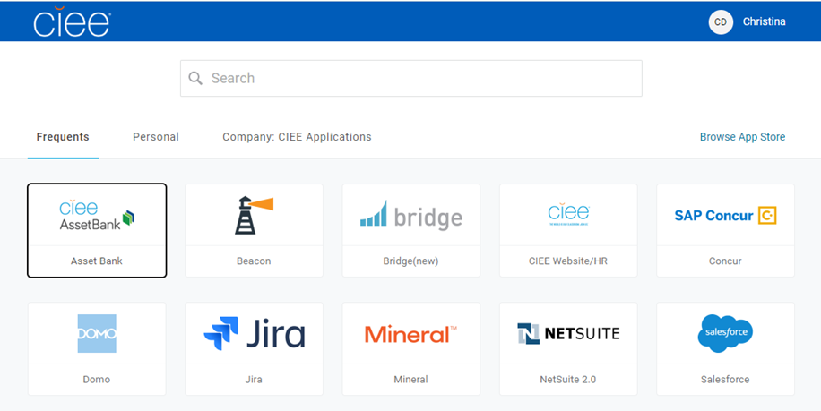
Access all of our internal apps in one spot!

Meet the Crew

This section links out to 3 employee resources.

Let’s shift to meeting the people that keep this plane flying! During your first couple of weeks, it’s important to piece together how your role fits into your larger team and the organization as a whole.

Please use the links in the airplane below to explore:
      - The Team (using the org. chart in our HR system, ADP)
      - Leadership (by reading their bios on our website)
      - Your Peers (using our social platform, Viva Engage)

PEERS

TEAM
LEADERSHIP

Flight Plan

This section has 1 manager resource, 1 shared resource and 1 employee resource.

It’s important for you and your manager to set measurable goals so that you can visualize what success looks like in your role. In addition to annual goal setting, checking-in on a regular basis ensures you’re provided with support when needed. Doing these things will help ensure that this relationship becomes long-term, and you can cash in on our cool CIEE Airmiles Rewards.

Resources/Templates in this section:
- OKR/Goal Setting Guide (for manager & employee)
- Weekly 1:1 Best Practices (for employee & manager)
- CIEE Airmiles Rewards & Other Rewards (for employee)

Ready for
Takeoff!

You did it - you completed your pre-boarding, got your boarding pass, met the crew and established your flight plan! Now, you’re officially ready to takeoff and we couldn’t be more excited that you’ve embarked on this journey with us.

At CIEE, we change lives and our alumni change the world – thank you for being part of the change!

The CIEE Team

